Callum Challinor

FVC

**Central Scotland Computers Review**

Contents

Part 1 2

Project summary information 2

Step 1(a) —WBS list (with task durations) 2

Step 1(b) — Resource list (with standard and overtime hourly rates) 2

Cost Overview Reports 3

Part 2 3

# Part 1

# Project summary information

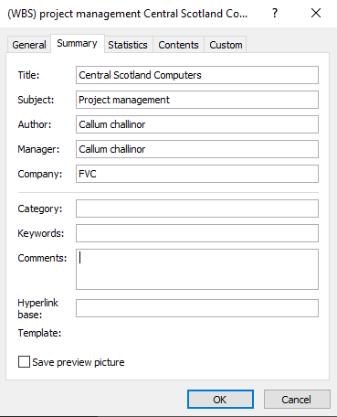

# Step 1(a) —WBS list (with task durations)



# Step 1(b) — Resource list (with standard and overtime hourly rates)



# Cost Overview Reports

  
  
Four Gantt charts











# Part 2

# Reason for review

The project triangle is something to consider because it represents time, scope, cost if I want to lower time it will come at the cost of either scope or cost, possibly even it is better for the overall project quality if cost is increased. To Decrease the time on the critical path like they want, this will come at either the cost or potentially the quality of the project.

The reason for this review is to display new options to the client that will reduce the projects end date by at least 5 working days, but this will come at the cost of quality or money.  
  
**Current project:**

**start: Mon 06/11/23**  
**Finish: Fri 14/06/24**

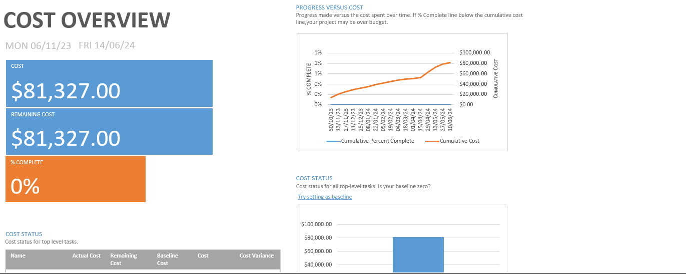

**Each stage cost:  
Planning: £17,208  
Development: £22,080  
Testing: £6,240  
Evaluation: £29,080**

# Option 1

The longest stage on the critical path is the development stage of the project, which is 67 days, an easy to reduce the time to completion would be to hire a new programmer for this stage would mean we would be able to reduce the number of days in the development stage by a little under half resulting in the stage being 35 days.  
  
the development stage currently costs £22080.0 the including a new programmer would mean the cost of the project would go up by £2960 making the new total.

**Effect on cost**

Increase in cost of £2960  
Total overall cost: £84,2879

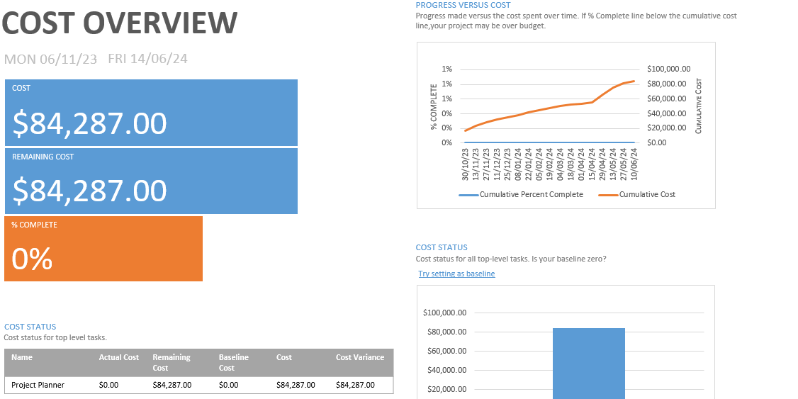  
**Effect on duration**

**Time Reduction: 20 days  
Finish: Fri 25/05/24**

# Option 2

Option 2 could be to shorten the testing stage of the project by reducing the “fix found bugs” task by 6 days although this will have an impact on quality by potentially leaving in less serious bugs in the code but doing this will save money and time.  
  
the current cost of the task fix found bugs is £2560 and each day cost £160 taking off 6 days would mean a reduction in price of £960.

**Effect on cost**

Cost reduced: £960

Total overall cost: £80,367

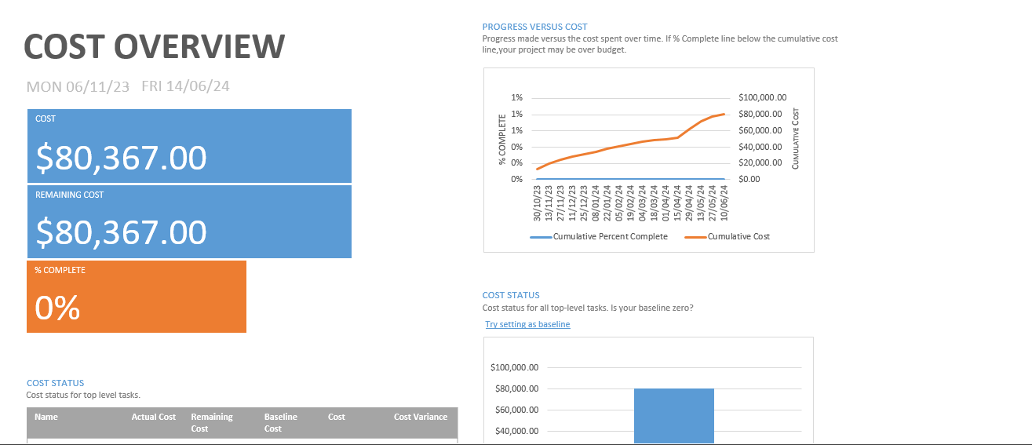

**Effect on duration**

**Time Reduction: 6 days**  
**Finish: Fri 8/06/24**

# Conclusion

Both options reduce the project time by at least 5 working days with option one reducing the project time by 20 days and option 2 reducing the project time by 6 days and reducing costs. But the quality of the project will suffer.  
  
I recommend option one which keeps the projects quality intact while decreasing time significantly but at the cost of money although the time saved will be more than worth the price.